PERSONALIZED FITNESS TRACKER & WORKOUT PLANNER
A MINI-PROJECT REPORT

Submitted by
Auxin Sam K A 241901012
Lukase S D 241901050
in partial fulfillment of the award of the degree of
BACHELOR OF ENGINEERING
IN
COMPUTER SCIENCE AND ENGINEERING
CYBER SECURITY
RAJALAKSHMI ENGINEERING COLLEGE, CHENNAI
An Autonomous Institute
CHENNAI
NOVEMBER 2025

BONAFIDE CERTIFICATE
Certified that this project “PERSONALIZED FITNESS TRACKER & WORKOUT PLANNER” is the bonafide work of “AUXIN SAM KA, LUKASE SD” who carried out the project work under my supervision.
SIGNATURE
Ms.RUPMALA R,
ASSISTANT PROFESSOR SG
Dept. of Computer Science and Engg,
Rajalakshmi Engineering College
Chennai

ABSTRACT
This project presents a Personalized Fitness Tracker & Workout Planner — a desktop application that helps users log activity, track calories, set goals and visualize progress. The application uses a Java Swing frontend for an interactive GUI and a SQL backend for reliable data management. Key features include user profile management, activity and nutrition logging, calorie tracking, goal setting, and progress visualization. The system aims to increase adherence to fitness plans by offering tailored recommendations and clear feedback.

ACKNOWLEDGEMENT
We express our sincere thanks to our beloved and honorable chairman MR. S. MEGANATHAN and the chairperson DR. M.THANGAM MEGANATHAN for their timely support and encouragement.
We are greatly indebted to our respected and honorable principal Dr. S.N. MURUGESAN for his able support and guidance.
No words of gratitude will suffice for the unquestioning support extended to us by our Head Of The Department Dr. E.M. MALATHY and our Deputy Head Of The Department Dr. J. MANORANJINI for being ever supporting force during our project work.
We also extend our sincere and hearty thanks to our internal guide Dr. V. JANANEE, for her valuable guidance and motivation during the completion of this project.
Our sincere thanks to our family members, friends and other staff members of computer science engineering.
1.Auxin Sam K A
2.Lukase S D

TABLE OF CONTENTS
ABSTRACT ........................................ iv
ACKNOWLEDGEMENT ................................ v
1. INTRODUCTION ................................ 1
1.1 Introduction ................................ 1
1.2 Scope of the Work .......................... 2
1.3 Problem Statement .......................... 3
1.4 Aim and Objectives ........................ 4
2. SYSTEM SPECIFICATIONS ...................... 5
2.1 Hardware Specifications .................... 5
2.2 Software Specifications .................... 6
3. MODULE DESCRIPTION .......................... 7
4. DATABASE DESIGN & CODING .................... 9
5. SCREENSHOTS ................................ 15
6. CONCLUSION AND FUTURE ENHANCEMENT ......... 18
REFERENCES .................................... 19

CHAPTER 1

INTRODUCTION
The Personalized Fitness Tracker & Workout Planner helps users manage their fitness journey by recording workouts, tracking calories, setting goals, and visualizing progress. Unlike generic fitness apps, this project focuses on personalization using user profiles (height, weight, age, gender) to provide tailored recommendations and accurate calorie estimations.

SCOPE OF THE WORK
This application targets desktop users who prefer an offline/responsive Java Swing application with a robust SQL backend. It supports activity logging, nutrition tracking, goal management, and basic analytics for progress monitoring.

PROBLEM STATEMENT
Many available fitness solutions are generic and may not adapt to individual user needs. This project aims to deliver a locally deployable, personalized system that stores data securely and provides actionable feedback to improve adherence and outcomes.

AIM AND OBJECTIVES OF THE PROJECT
Aim: Build a desktop-based personalized fitness tracker with Java frontend and SQL backend.
Objectives:
- Implement user profile management for accurate metrics.
- Allow logging/editing of activities and nutrition entries.
- Provide calorie calculations and daily summaries.
- Enable goal setting with progress tracking and visualizations.

CHAPTER 2

SYSTEM SPECIFICATIONS

HARDWARE SPECIFICATIONS
Processor : Intel i5 or equivalent
Memory Size : 8GB (Minimum)
HDD : 1 TB (Minimum)

SOFTWARE SPECIFICATIONS
Operating System : WINDOWS 10 / 11
Front-End : Java (Swing)
Back-End : MySQL 8.0 (or SQLite for lightweight setups)
Language : Java, SQL
Development IDE : IntelliJ IDEA (recommended)

CHAPTER 3

MODULE DESCRIPTION
The application is divided into logical modules:
1. User Management:
- Register, login, and maintain user profile (height, weight, age, gender, activity level).
2. Activity Logging:
- Add/edit/delete workout entries (type, duration, intensity, calories burned, timestamp).
3. Nutrition Logging:
- Add meals with calorie counts to track intake.
4. Goal Management:
- Define fitness goals (weight loss, strength, endurance) with target metrics and deadlines.
5. Analytics & Visualization:
- Provide charts showing activity breakdowns, calorie balance and goal progress.

CHAPTER 4

DATABASE DESIGN
Suggested schema (MySQL):
CREATE TABLE users (
user_id INT AUTO_INCREMENT PRIMARY KEY,
name VARCHAR(100),
email VARCHAR(150),
password_hash VARCHAR(255),
age INT,
gender VARCHAR(10),
height_cm FLOAT,
weight_kg FLOAT,
created_at DATETIME DEFAULT CURRENT_TIMESTAMP
);
CREATE TABLE activities (
activity_id INT AUTO_INCREMENT PRIMARY KEY,
user_id INT,
type VARCHAR(50),
duration_minutes INT,
intensity VARCHAR(20),
calories_burned FLOAT,
activity_date DATETIME,
FOREIGN KEY (user_id) REFERENCES users(user_id)
);
CREATE TABLE nutrition (
meal_id INT AUTO_INCREMENT PRIMARY KEY,
user_id INT,
meal_time DATETIME,
description VARCHAR(255),
calories FLOAT,
FOREIGN KEY (user_id) REFERENCES users(user_id)
);
CREATE TABLE goals (
goal_id INT AUTO_INCREMENT PRIMARY KEY,
user_id INT,
goal_type VARCHAR(50),
target_value FLOAT,
start_date DATE,
end_date DATE,
achieved BOOLEAN DEFAULT FALSE,
FOREIGN KEY (user_id) REFERENCES users(user_id)
);

SAMPLE JAVA (Swing) SNIPPET
package org.fitbliss.ui;

import org.fitbliss.service.FitnessService;
import org.fitbliss.model.Activity;

import javax.swing.*;
import java.awt.*;
import java.awt.event.ActionEvent;
import java.time.LocalDateTime;
import java.util.List;

/**
* Main application frame with tabbed panes.
*/
public class MainFrame extends JFrame {

private final FitnessService service = new FitnessService();
private int currentUserId = 1; // demo: assume user 1 is logged in

public MainFrame() {
super("FitBliss - Personalized Fitness Tracker");
setDefaultCloseOperation(JFrame.EXIT_ON_CLOSE);
setSize(1000, 700);
setLocationRelativeTo(null);

JTabbedPane tabs = new JTabbedPane();

tabs.addTab("Dashboard", createDashboardPanel());
tabs.addTab("Log Activity", createLogActivityPanel());
tabs.addTab("Activity History", createActivityHistoryPanel());
tabs.addTab("Nutrition", createNutritionPanel());
tabs.addTab("Profile", createProfilePanel());
tabs.addTab("Goals", createGoalsPanel());

add(tabs, BorderLayout.CENTER);
}

private JPanel createDashboardPanel() {
JPanel panel = new JPanel(new BorderLayout());
panel.setBorder(BorderFactory.createEmptyBorder(8,8,8,8));

JLabel title = new JLabel("Dashboard");
title.setFont(new Font("SansSerif", Font.BOLD, 20));
panel.add(title, BorderLayout.NORTH);

// summary + chart area
JPanel center = new JPanel(new GridLayout(1,2,8,8));

// Left: summary (basic labels)
JPanel summary = new JPanel();
summary.setLayout(new BoxLayout(summary, BoxLayout.Y_AXIS));
summary.add(new JLabel("Welcome back!"));
// load some summary data
try {
List<Activity> activities = service.getActivitiesForUser(currentUserId);
int totalMinutes = activities.stream().mapToInt(Activity::getDurationMinutes).sum();
int totalCalories = activities.stream().mapToInt(Activity::getCaloriesBurned).sum();
summary.add(new JLabel("Total workouts: " + activities.size()));
summary.add(new JLabel("Total minutes: " + totalMinutes));
summary.add(new JLabel("Total calories (records): " + totalCalories));
} catch (Exception e) {
summary.add(new JLabel("Summary load failed: " + e.getMessage()));
}

center.add(summary);

// Right: placeholder chart panel (we will create a chart using JFreeChart)
ChartPanelWrapper chartPane = new ChartPanelWrapper(); // see below class
center.add(chartPane.getPanelWithChart(currentUserId));

panel.add(center, BorderLayout.CENTER);
return panel;
}

private JPanel createLogActivityPanel() {
JPanel p = new JPanel(new GridBagLayout());
GridBagConstraints c = new GridBagConstraints();
c.insets = new Insets(6,6,6,6);
c.gridx = 0; c.gridy = 0; c.anchor = GridBagConstraints.WEST;
p.add(new JLabel("Activity Type:"), c);
c.gridx = 1; JTextField typeField = new JTextField(20); p.add(typeField, c);

c.gridx = 0; c.gridy++;
p.add(new JLabel("Duration (minutes):"), c);
c.gridx = 1; JTextField durationField = new JTextField(6); p.add(durationField, c);

c.gridx = 0; c.gridy++;
p.add(new JLabel("Intensity:"), c);
c.gridx = 1;
JComboBox<String> intensityBox = new JComboBox<>(new String[]{"low","moderate","high"});
p.add(intensityBox, c);

c.gridx = 0; c.gridy++;
p.add(new JLabel("Calories (optional):"), c);
c.gridx = 1; JTextField caloriesField = new JTextField(8); p.add(caloriesField, c);

c.gridx = 0; c.gridy++;
p.add(new JLabel("Notes:"), c);
c.gridx = 1; JTextArea notesArea = new JTextArea(4, 20); p.add(new JScrollPane(notesArea), c);

c.gridx = 0; c.gridy++;
JButton addBtn = new JButton("Log Activity");
p.add(addBtn, c);

addBtn.addActionListener((ActionEvent e) -> {
try {
Activity a = new Activity();
a.setUserId(currentUserId);
a.setActivityType(typeField.getText().trim());
a.setDurationMinutes(Integer.parseInt(durationField.getText().trim()));
a.setIntensity((String) intensityBox.getSelectedItem());
String cals = caloriesField.getText().trim();
a.setCaloriesBurned(cals.isEmpty() ? 0 : Integer.parseInt(cals));
a.setNotes(notesArea.getText());
a.setActivityDate(LocalDateTime.now());

service.logActivity(a);
JOptionPane.showMessageDialog(this, "Activity logged!");
// clear fields
typeField.setText("");
durationField.setText("");
caloriesField.setText("");
notesArea.setText("");
} catch (Exception ex) {
JOptionPane.showMessageDialog(this, "Error: " + ex.getMessage(), "Error", JOptionPane.ERROR_MESSAGE);
}
});

return p;
}

private JPanel createActivityHistoryPanel() {
JPanel panel = new JPanel(new BorderLayout());
panel.setBorder(BorderFactory.createEmptyBorder(8,8,8,8));
String[] cols = {"Date", "Type", "Duration (min)", "Intensity", "Calories", "Notes"};
DefaultTableModel model = new DefaultTableModel(cols, 0);
JTable table = new JTable(model);

try {
List<Activity> list = service.getActivitiesForUser(currentUserId);
for (Activity a : list) {
model.addRow(new Object[]{
a.getActivityDate(),
a.getActivityType(),
a.getDurationMinutes(),
a.getIntensity(),
a.getCaloriesBurned(),
a.getNotes()
});
}
} catch (Exception e) {
model.addRow(new Object[]{"Load failed: " + e.getMessage(), "", "", "", "", ""});
}

panel.add(new JScrollPane(table), BorderLayout.CENTER);
return panel;
}

private JPanel createNutritionPanel() {
JPanel p = new JPanel();
p.add(new JLabel("Nutrition tracking will be implemented similarly to Activity logging."));
return p;
}

private JPanel createProfilePanel() {
JPanel p = new JPanel();
p.add(new JLabel("Profile management UI (update weight, height, activity level etc.)"));
return p;
}

private JPanel createGoalsPanel() {
JPanel p = new JPanel();
p.add(new JLabel("Goals UI - add/monitor goals and progress."));
return p;
}

public static void main(String[] args) {
SwingUtilities.invokeLater(() -> {
MainFrame mf = new MainFrame();
mf.setVisible(true);
});
}
}
/* Example: simple Swing form to add an activity (conceptual snippet) */
JFrame frame = new JFrame("Add Activity");
JPanel panel = new JPanel();
JTextField typeField = new JTextField(20);
JTextField durationField = new JTextField(5);
JButton submit = new JButton("Save");
submit.addActionListener(e -> {
String type = typeField.getText();
int duration = Integer.parseInt(durationField.getText());
// compute calories (example)
double calories = computeCalories(type, duration, userWeightKg);
// insert into DB using JDBC
});
frame.add(panel);
frame.pack();
frame.setVisible(true);

SAMPLE SAMPLE SQL (JDBC) INSERT
package org.fitbliss.dao;

import org.fitbliss.db.DBConnection;
import org.fitbliss.model.Activity;

import java.sql.*;
import java.time.LocalDateTime;
import java.util.ArrayList;
import java.util.List;

public class ActivityDao {

public Activity create(Activity activity) throws SQLException {
String sql = "INSERT INTO activities (user_id, activity_type, duration_minutes, intensity, calories_burned, activity_date, notes) VALUES (?, ?, ?, ?, ?, ?, ?)";
try (Connection conn = DBConnection.getConnection();
PreparedStatement ps = conn.prepareStatement(sql, Statement.RETURN_GENERATED_KEYS)) {
ps.setInt(1, activity.getUserId());
ps.setString(2, activity.getActivityType());
ps.setInt(3, activity.getDurationMinutes());
ps.setString(4, activity.getIntensity());
ps.setInt(5, activity.getCaloriesBurned());
ps.setTimestamp(6, Timestamp.valueOf(activity.getActivityDate()));
ps.setString(7, activity.getNotes());
ps.executeUpdate();
try (ResultSet rs = ps.getGeneratedKeys()) {
if (rs.next()) {
activity.setId(rs.getLong(1));
}
}
}
return activity;
}

public List<Activity> findByUser(int userId) throws SQLException {
String sql = "SELECT * FROM activities WHERE user_id = ? ORDER BY activity_date DESC";
List<Activity> list = new ArrayList<>();
try (Connection conn = DBConnection.getConnection();
PreparedStatement ps = conn.prepareStatement(sql)) {
ps.setInt(1, userId);
try (ResultSet rs = ps.executeQuery()) {
while (rs.next()) {
Activity a = mapRow(rs);
list.add(a);
}
}
}
return list;
}

private Activity mapRow(ResultSet rs) throws SQLException {
Activity a = new Activity();
a.setId(rs.getLong("id"));
a.setUserId(rs.getInt("user_id"));
a.setActivityType(rs.getString("activity_type"));
a.setDurationMinutes(rs.getInt("duration_minutes"));
a.setIntensity(rs.getString("intensity"));
a.setCaloriesBurned(rs.getInt("calories_burned"));
Timestamp ts = rs.getTimestamp("activity_date");
if (ts != null) a.setActivityDate(ts.toLocalDateTime());
a.setNotes(rs.getString("notes"));
return a;
}

// call stored procedure add_activity
public void addActivityUsingProcedure(Activity activity) throws SQLException {
String call = "{CALL add_activity(?,?,?,?,?,?)}";
try (Connection conn = DBConnection.getConnection();
CallableStatement cs = conn.prepareCall(call)) {
cs.setInt(1, activity.getUserId());
cs.setString(2, activity.getActivityType());
cs.setInt(3, activity.getDurationMinutes());
cs.setString(4, activity.getIntensity());
cs.setInt(5, activity.getCaloriesBurned());
cs.setString(6, activity.getNotes());
cs.execute();
}
}

// Delete/update operations could be added below...
}
PreparedStatement ps = conn.prepareStatement(
"INSERT INTO activities (user_id, type, duration_minutes, intensity, calories_burned, activity_date) VALUES (?,?,?,?,?,?)"
);
ps.setInt(1, userId);
ps.setString(2, type);
ps.setInt(3, duration);
ps.setString(4, intensity);
ps.setDouble(5, calories);
ps.setTimestamp(6, new Timestamp(System.currentTimeMillis()));
ps.executeUpdate();
SQL — schema, sample data, stored procedures (MySQL 8.0)
-- fitbliss_schema.sql
-- Schema for Personalized Fitness Tracker (MySQL 8.0)
-- Tables: users, activities, nutrition, goals
-- Create database
DROP DATABASE IF EXISTS fitbliss;
CREATE DATABASE fitbliss CHARACTER SET utf8mb4 COLLATE utf8mb4_unicode_ci;
USE fitbliss;

-- USERS table: stores user profiles
CREATE TABLE users (
id INT AUTO_INCREMENT PRIMARY KEY,
username VARCHAR(64) NOT NULL UNIQUE,
password_hash VARCHAR(255) NOT NULL, -- store password hash
full_name VARCHAR(128),
email VARCHAR(128) UNIQUE,
gender ENUM('male','female','other') DEFAULT 'other',
dob DATE,
height_cm DECIMAL(5,2),
weight_kg DECIMAL(6,2),
activity_level ENUM('sedentary','light','moderate','active','very_active') DEFAULT 'moderate',
created_at TIMESTAMP DEFAULT CURRENT_TIMESTAMP,
updated_at TIMESTAMP DEFAULT CURRENT_TIMESTAMP ON UPDATE CURRENT_TIMESTAMP
);

-- ACTIVITIES table: workout logs
CREATE TABLE activities (
id BIGINT AUTO_INCREMENT PRIMARY KEY,
user_id INT NOT NULL,
activity_type VARCHAR(100) NOT NULL, -- e.g., "Running", "Cycling", "Strength"
duration_minutes INT NOT NULL, -- integer minutes
intensity ENUM('low','moderate','high') DEFAULT 'moderate',
calories_burned INT NULL, -- may be computed/stored
activity_date DATETIME DEFAULT CURRENT_TIMESTAMP,
notes TEXT,
FOREIGN KEY (user_id) REFERENCES users(id) ON DELETE CASCADE
);

-- NUTRITION table: meals & calories
CREATE TABLE nutrition (
id BIGINT AUTO_INCREMENT PRIMARY KEY,
user_id INT NOT NULL,
meal_time DATETIME DEFAULT CURRENT_TIMESTAMP,
description VARCHAR(255),
calories_intake INT NOT NULL,
protein_g DECIMAL(6,2),
carbs_g DECIMAL(6,2),
fat_g DECIMAL(6,2),
FOREIGN KEY (user_id) REFERENCES users(id) ON DELETE CASCADE
);

-- GOALS table: user goals (weight, calories or activity)
CREATE TABLE goals (
id INT AUTO_INCREMENT PRIMARY KEY,
user_id INT NOT NULL,
goal_type ENUM('weight','calories','activity') NOT NULL,
target_value DECIMAL(8,2) NOT NULL,
unit VARCHAR(16) NOT NULL, -- e.g., 'kg', 'kcal', 'minutes/week'
start_date DATE DEFAULT CURRENT_DATE,
end_date DATE NULL,
achieved BOOLEAN DEFAULT FALSE,
created_at TIMESTAMP DEFAULT CURRENT_TIMESTAMP,
FOREIGN KEY (user_id) REFERENCES users(id) ON DELETE CASCADE
);

-- Indexes for performance
CREATE INDEX idx_activities_user_date ON activities(user_id, activity_date);
CREATE INDEX idx_nutrition_user_date ON nutrition(user_id, meal_time);

-- Sample data (small set)
INSERT INTO users (username, password_hash, full_name, email, gender, dob, height_cm, weight_kg, activity_level)
VALUES
('alice', 'hash_placeholder', 'Alice Kumar', 'alice@example.com', 'female', '1992-05-15', 165.0, 62.0, 'moderate'),
('bob', 'hash_placeholder', 'Bob Singh', 'bob@example.com', 'male', '1988-10-01', 178.0, 80.5, 'active');

INSERT INTO activities (user_id, activity_type, duration_minutes, intensity, calories_burned, activity_date, notes)
VALUES
(1, 'Running', 30, 'high', 340, '2025-10-01 07:30:00', 'Morning interval run'),
(1, 'Yoga', 45, 'low', 160, '2025-10-02 18:00:00', 'Evening flow'),
(2, 'Cycling', 60, 'moderate', 600, '2025-10-03 06:30:00', 'Road ride');

INSERT INTO nutrition (user_id, meal_time, description, calories_intake, protein_g, carbs_g, fat_g)
VALUES
(1, '2025-10-01 08:45:00', 'Oatmeal + banana', 350, 10, 60, 7),
(1, '2025-10-01 13:00:00', 'Chicken salad', 450, 35, 20, 18);

INSERT INTO goals (user_id, goal_type, target_value, unit, start_date, end_date)
VALUES
(1, 'weight', 58.0, 'kg', '2025-10-01', '2026-01-01'),
(1, 'activity', 150.0, 'minutes/week', '2025-10-01', NULL);

-- Stored procedure: add_activity (computes estimated calories if null)
DELIMITER //
CREATE PROCEDURE add_activity (
IN p_user_id INT,
IN p_activity_type VARCHAR(100),
IN p_duration_minutes INT,
IN p_intensity ENUM('low','moderate','high'),
IN p_calories INT,
IN p_notes TEXT
)
BEGIN
DECLARE computed_cal INT;
IF p_calories IS NULL OR p_calories = 0 THEN
-- Simple heuristic: calories = duration_minutes * intensity_factor
IF p_intensity = 'low' THEN
SET computed_cal = p_duration_minutes * 4; -- placeholder factor
ELSEIF p_intensity = 'moderate' THEN
SET computed_cal = p_duration_minutes * 7;
ELSE
SET computed_cal = p_duration_minutes * 11;
END IF;
ELSE
SET computed_cal = p_calories;
END IF;

INSERT INTO activities (user_id, activity_type, duration_minutes, intensity, calories_burned, notes)
VALUES (p_user_id, p_activity_type, p_duration_minutes, p_intensity, computed_cal, p_notes);
END;
//
DELIMITER ;

-- Stored procedure: get_weekly_summary (returns total minutes and calories per user for last 7 days)
DELIMITER //
CREATE PROCEDURE get_weekly_summary (IN p_user_id INT)
BEGIN
SELECT
DATE(activity_date) AS day,
SUM(duration_minutes) AS total_minutes,
SUM(calories_burned) AS total_calories
FROM activities
WHERE user_id = p_user_id
AND activity_date >= DATE_SUB(CURDATE(), INTERVAL 6 DAY)
GROUP BY DATE(activity_date)
ORDER BY day;
END;
//
DELIMITER ;

CHAPTER 5

SCREENSHOTS
1 Login / Registration Page
2 User Profile
3 Activity Logging
4 Nutrition Entry
5 Goal Progress Chart
1.Login/Registration Page:
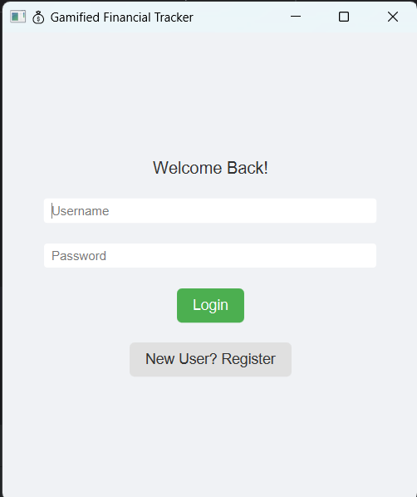
2.Terms and conditions:
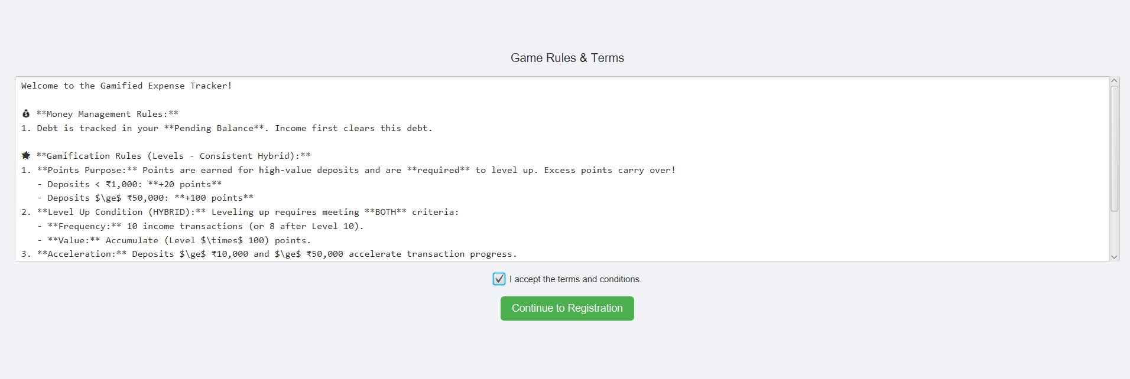
3.User profile:
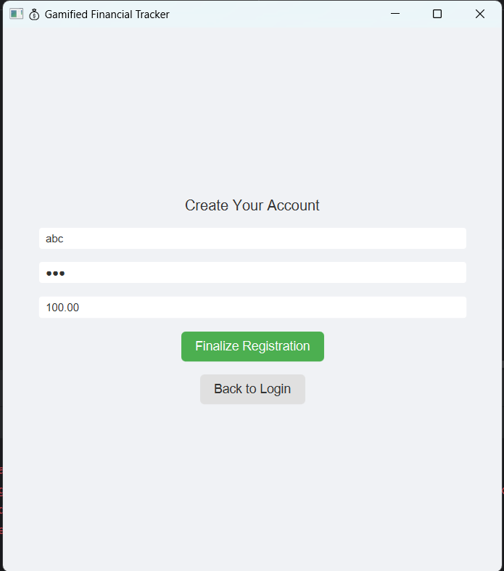

CHAPTER 6

CONCLUSION AND FUTURE ENHANCEMENT
The Personalized Fitness Tracker provides a focused desktop solution for users to plan and monitor fitness activities. Future enhancements include:
- Integration with wearable devices (heart rate, steps).
- AI-powered workout suggestions based on user history.
- Web/mobile front-ends for cross-platform access.
- Enhanced security and encryption for sensitive health data.

REFERENCES
1. Project brief: Personalized-Fitness-Tracker-and-Workout-Planner (user-provided).
2. MySQL documentation and JDBC guides.
3. Java Swing tutorials and best practices.
4. Grand View Research (market insights referenced in project brief).

